FIRST AND FAMILY NAME
TITLE OF THE PAPER

TITLE OF THE PAPER IN ENGLISH

S u m m a r y

Title of the paper in Polish should be printed in black, the title in English in grey, the text should be centralised, font 14, space before 36 and after 12 points.

Summaries should be written in font 9 with an indentation of 1cm (please do not use tabulator when making an indentation!). Summaries should not exceed ten lines of text each (both should be placed on the first page of the paper!). Space before and after six points.

Keywords: keywords should be written in italics, in font 9

A b s t r a c t

The paper summarizes the methods of biogas production and management as the one of waste management and energy requirements.. Some biogas utilization investments based on sustainable development were characterized.

Keywords: energy biogas utilization

Denotations
A_{R} – γ reactor cross-section area
b – stechiometric coefficient
ω – angle velocity [rad/s]
A – coefficient for coastal / boundary ??? zone C = 0,
y – distance of measurement point from stream limiting wall,
R – conduit radius of circular cross section,
D - conduit diameter.
1. Title of the chapter; font 10 bold, space before 24, after 12 points
1.1. Title of the subsection, text centralised (font 10, space before 12 after 6 points)
1.1.1. Title of the subsequent section, standard font 10, space before 6 after 3 points
The text below is an example of the font format (10, Times New Roman CE) and spaces between lines (single interline) aligned.
For the correct format margins should be set up: top 5.7cm, bottom5.1cm, right and left one 4.0 cm. Page numbers should be at the top of the page in the heading, aligning to the outside.
The basic text should be written with an indentation (0.5 cm). Do not make indentations using spacing! (page layout in Format/Tabulator option)
The following may be used to distinguish the text: bold, italics, bold italics, s p a c i n g o u t (page layout). Do not use underlining. Literature notes, references should be in square brackets [1] in the order they are quoted.
The paper has to be written in MS Office Word in 2003 or later version and cannot exceed 6 pages of the text (when the text does not reach 6 pages it should be reduced to an even number of pages, e.g. 4).
Photographs should be placed in the text, access to graphic file (reading the file) must not be activated. Resolution of the photographs should be adjusted in such a way that the best quality is achieved and cannot be smaller than 300 dpi, the “volume” of one photograph cannot exceed 1 Mb.
Text file should be sent in an electronic form to the address of the Organization Committee – the volume of the file together with photographs should not exceed 10 Mb. The file cannot be divided – it should be sent as a whole. Additionally, the file should be sent in an electronic form on a CD together with photographs (in a separate catalogue) to the address of the conference office: Zakład Budownictwa i Fizyki Budowli L-17, ul. Warszawska 24, 31-155 Kraków.
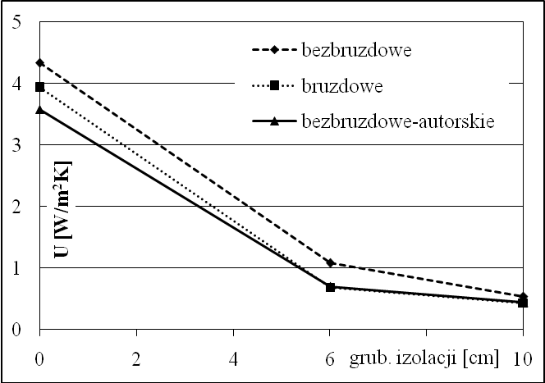
Fig. 1. Captions under figures in Polish and English should be written in font 9, centralised; between them a 4 point space, after 12 points.
Fig.1 Distribution of p_{cr} values depending on the core thickness h₂ and thickness of outer layer h′ of plate loaded on inner edge
T a b l e 1

Values of averaged coefficient U[W/m²K] in area of reinforcement
h₂ [m] | h’ = 0,005 m |  | h’ = 0,001 m
h₂ [m] | G₂ = 5 MPa | G₂ = 15 MPa | G₂ = 5 MPa | G₂ = 15 MPa
0,0025 | 43,53 | 93,49 | 61,76 | 109,52
0,005 | 64,12 | 143,91 | 75,61 | 144,31

Table number should be spaced out (2 points), space before 12 points, after 6 points. The name of the table should be written in bold, the space before and after 6 points. The text within the table in font 9.

L i t e r a t u r e
[1] Literature should be written in font 10, with n a m e s s p a c e d o u t, book titles in italics without quotation marks, periodical titles in a Roman type (vertical). Literature cited in the text should be in square brackets. Literature in the order of citing.
[2] C i m o c h o w i c z - R y b i c k a M., Biomass methanogenic activity as the evaluation basis of the inhibiting influence of chosen pesticides and chromium (III) on methane fermentation process, doctoral dissertation, Cracow University of Technology, Kraków 1999.
[3] G r a d y C.P.L. jr., D a i g g e r G.T., L i m H.C., Biological Wastewater Treatment, Second edition, Anaerobic Processes, chapter 13, 1999.
[4] C i m o c h o w i c z - R y b i c k a M., R y b i c k i S.M., Selected aspect of risk minimization in energy recovery system, Materials from Polish-Swedish Seminary ,,Integration and Optimisation of Urban Sanitation Systems”, Gdańsk 2003, 99-108.
[5] Ż e g l i n - K u r b i e l K., B a n a ś J., C i m o c h o w i c z - R y b i c k a M., New biotechnologies and sewage sediments to fulfill European Union requirements, Technical Periodical booklet 4-Ś/2003, Published by Cracow University of Technology, Kraków 2003.

MATHEMATICAL FORMULAE

Mathematical formulae should be written in 10 point font ( as in the basic text).

In italics are denoted::
- letters denoting numbers, variables and constant, as well as geometrical points;
- function denotations, e.g. f(x);
- letter denotations and initialisms occurring in sub- and superscripts (apart from double or tripple letters, e.g. i_{kr,,} X_{we,} X_{wy} formed from the first letters of one word);
- sign of incomplete differential ,. which can also be written in a Roman type
In Roman type are denoted:
- Arabic and Roman numbers, also in sub- and superscripts e.g. x₁;
- Greek letters, also in mathematical notation, e.g. α;
- units of measurements (denotations and abbreviations), e.g. m, g;
- abbreviations consisting of two or more letters, e.g. Re (Reynolds number);
- constant functional symbols, such as: ar, arc, arccos, arcosh, arcsin, arctg, arctgh, arg, arsinh, artgh, clg, const, cos, cosec, cosech, cosh, cov, ctg, ctgh, det, diag, div, exp, grad, Im, inf, Ig, lim inf, lim sup, In, log, max, min, mod, non, Re, rot, sec, sech, sgn, sinh, sup, tg, tgh; differential sign ∂, which can also be written in italics;
- Special numbers: π and e (base of natural logarithm)
- probability P (A), expected value E(x), random variance D2(X), increment sign Δ (delta).
Matrices are written in Roman bold type (e.g. A,I, E),
Vectors are written in bold italics

$\bar{v}=A+B\text{ln}\frac{y}{R}+C\frac{y}{R}$ (1)

where:
A, B, C – coefficients for boundary zone C = 0,
y – distance of measuring point from the limiting stream wall,
R – radius of circular cross section of conductor
D – conductor diameter.

$\bar{E}=\int{ψ×\left(r,t\right)\left[−\frac{h^{2}}{2m_{0}}∇^{2}+V\left(r\right)+r\left[∇A_{\text{mech}}\right]\right]}ψ\left(r,t\right)d_{r}$ (2)

where:
Ψ (r, t), Ψ*(r, t) – conjugate wave functions.

SET UPS IN MS WORD EQUATION EDITOR

Click equation editor icon on the tool bar: view/tool bars/adjust/commands/insert/equation editor. A new tool bar will appear at the window(screen) top in which style, size and spacing is to be defined (as below).

(please do not use signs:*,#, etc.) title (degree), first and family name, name of the institute, faculty, university/institution, (font 9)

